Introduction
This document explains how to use wiwLogs node.
wiwLogs manages logs messages and responses.

The flow
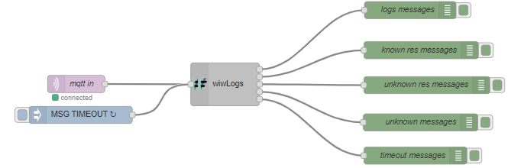
This flow has been created with node v10.16.0 and Node-RED v0.20.7.

Third party dependencies
A Mqtt broker must be running. See mqttBroker document for more information.

Explanation
This flow demonstrates how to use wiwLogs to manage logs messages and responses received from What Is What.

First line
Mqtt node receives logs messages from What Is What. Messages are split into four different categories. See wiwLogs’ documentation for the list of categories.
Further more, this node checks the reception of response messages in due time of. If the input is the string “MSG TIMEOUT”, it checks if there are messages on timeout (in this case, every 2 seconds, depending on the inject node settings). Messages in timeout are sent on the fifth output. See wiwLogs’ documentation for more information.

Note
Please make sure to use the right Mqtt broker settings in the Mqtt client setup.

